SOT227 Flanged Base Plate RTP200 Thick Film Dual Resistor
- The RTP200 thick-film non-inductive power resistor, also known as the SOT227-packaged high-power resistor, utilizes the SOT227 package—an internally insulated, four-terminal power semiconductor package. It employs SMD/SMT mounting and features standard threaded holes in the base for easy mounting on heat sinks.
- The RTP200 resistor is rated at 200W and features a bottom-mounted heat sink flange design for excellent thermal dissipation. Typically designed for current sensing, energy absorption and dissipation, RC snubbers, high-speed switching, and high-frequency transmission circuits. Also commonly used in voltage regulation, constant power loads, and low-energy pulse loads. Applications span industries such as industrial lasers, welding equipment, test equipment, instrumentation, UPS systems, automotive, and switch-mode power supplies in end products.

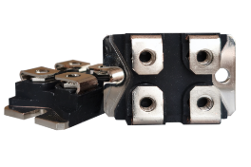

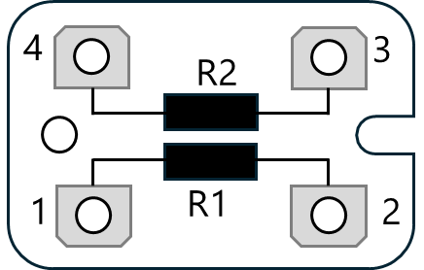

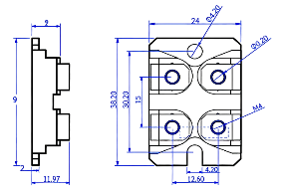
Technical Specifications
Rated Power | Insulation Resistance | Maximum voltage | Output terminal | Insulation Withstand Voltage
200W | ≥10GΩ | 700VDC | Tin-plated copper wire | 2000VAC
Resistance range | Operating Temperature | Optional precision | TC | Installation torque
0.1Ω | -55℃ | ±0.5% | ±100 | M4 screw 1.5Nm
1MΩ | +170℃ | ±5% | ppm/℃ | M4 screw 1.5Nm



Performance

Test Item | Perf Req | Test Standard
Power Durability | ΔR≤±1R% | Rated power 1000h, baseplate temperature ≤85℃
Humidity Resistance | ΔR≤±0.25R% | MIL-Std-202, Method 106
Thermal Shock | ΔR≤±1R% | MIL-Std-202, Method 103, Condition D
Thermal Shock | ΔR≤±0.3R% | -65°C to 155°C, 5 cycles
High-Frequency Vibration | ΔR≤±0.2%R | MIL-Std-202, Method 204, Condition D

